**Login AS fatos40**

**Name RAMRATAN SHARMA**

**Roll Number 205120081**

**5. (P-I) Write a C program to a create child process and display the process ID of parent and child processes also show the Zombie property of it.**

#include <stdio.h>

#include <stdlib.h>

#include <sys/types.h>

#include <sys/time.h>

#include <unistd.h>

int main()

{

int pid;

printf("\nCalling fork\n");

pid = fork();

char cmd[] = "ps -e -o s,pid,ppid";

if(pid == 0)

{

printf("\nChild process started.");

printf("\nchild process id is: %d", getpid());

printf("\nParent process id is: %d", getppid());

system(cmd);

exit(0);

}

else if (pid > 0)

{

printf("\nparent process started.");

printf("\nParent process id: %d", getpid());

printf("\nPutting parent process to sleep state");

sleep(30);

system(cmd);

}

return 0;

}

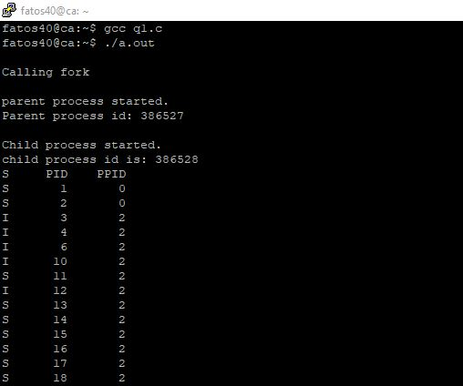

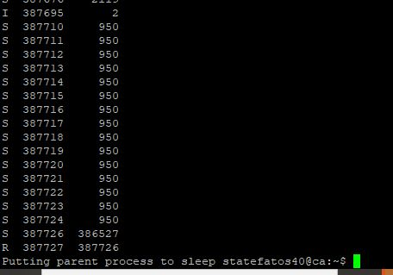

**5 (P-II) Write a C program to implement a task assignment problem for the processor, based on the task burst time (Hint: smallest burst time task get service first-Show the necessary outcomes).**

#include <stdio.h>

#include <stdlib.h>

void lru(int arr[], int n, int frames);

int search(int arr[], int n, int key)

{

for (int i = 0; i < n; i++)

{

if (arr[i] == key)

return i;

}

return -1;

}

int main()

{

int arr[] = {1,2,3,4,2,1,5,6,2,1,2,3,7,6,3,2,1,2,3,6};

int frames = 4;

lru(arr, 12, frames);

return 0;

}

void lru(int arr[], int n, int frames)

{

printf("Pages: ");

for (int i = 0; i < n; i++)

{

printf(" %d ", arr[i]);

}

printf("\n\n");

int hits = 0, miss = 0, b;

int *buffer;

buffer = (int *)malloc(sizeof(int) * frames);

for (int i = 0; i < frames; i++)

{

buffer[i] = 0;

}

int index, temp;

for (int p = 0; p < n; p++)

{

index = search(buffer, frames, arr[p]);

if (index >= 0)

{

hits++;

b = 1;

temp = buffer[index];

for (int i = index - 1; i >= 0; i--)

{

buffer[i + 1] = buffer[i];

}

buffer[0] = temp;

}

else

{

miss++;

for (int i = frames - 2; i >= 0; i--)

{

buffer[i + 1] = buffer[i];

}

buffer[0] = arr[p];

b = 0;

}

}

float hitp = ((float)(hits*100)/n);

float misp = ((float)(miss*100)/n);

printf("Page Hits %d, Page Faults %d, Hit Percent - %f, Page fault Percent- %f\n", hits, miss,hitp,misp);

}

